WEBSITE PROJECT PROPOSAL PART 1
Subject Name & Code: Web Development WEDE5020
Student Name: Prudence Mogadime
Student Number: ST10526567
Institution: The Independent Institute of Education (IIE)
Date: 21 August 2026

Table of Contents

- 1. Organisation Overview
  - Background & History
  - Mission and Vision Statements
  - Target Audience Analysis
- 2. Website Goals and Objectives
  - Primary Objectives
  - Key Performance Indicators (KPIs)
- 3. Current Website Analysis
  - Strengths and Limitations
  - Opportunities for Improvement
- 4. Proposed Website Features & Functionality
  - Essential Page Structure
  - Interactive Elements & Forms
- 5. Design and User Experience (UX)
  - Colour Palette & Visual Identity
  - Typography & Hierarchy
  - Low-Fidelity Wireframes
- 6. Technical Requirements
  - Domain & Hosting Specifications
  - Tools & Technologies (HTML5, VS Code, Git)
- 7. Project Planner & Timeline
  - Implementation Schedule
  - Key Milestones
- 8. Budget Allocation
- 9. References

1.Organisation Overview
Small business
- Name: Bophelo Mother & Child Healthcare Centre (Hypothetical organisation)
- Brief History: Bophelo Mother & Child Healthcare Centre was established in 2018 in Polokwane, Limpopo, as a community-driven non-profit healthcare initiative. The centre was founded to address critical healthcare gaps in rural and peri-urban Limpopo, specifically focusing on maternal care, neonatal support, and early childhood wellness. Over the past few years, the centre has expanded its outreach to provide preventative care and health education to vulnerable families across the district.
- Mission Statement: To provide accessible, compassionate, and high-quality maternal and child healthcare services to underserved communities, empowering families through continuous health education and preventative care.
- Vision Statement: To eliminate preventable maternal and infant health complications across Limpopo by fostering a healthy, well-supported community network.
- Target Audience: Expectant mothers, parents and primary caregivers of infants and young children, local community volunteers, and potential healthcare donors or NPO sponsors.
2. Website Goals and Objectives
- Specific Goals:
  - Build a functional, easy-to-navigate website that acts as a central hub for clinic information and operating hours.
  - Streamline patient interaction by allowing visitors to submit general health and appointment enquiries online.
  - Create a dedicated gateway for community members to apply for volunteer positions or submit NPO sponsorship inquiries.
  - Educate the community by providing clear summaries of available maternal and child medical services.
- Key Performance Indicators (KPIs):
  - Achieve a minimum of 400 to 500 unique visitors per month within the first six months of launch.
  - Increase digital enquiry submissions (patient appointments and volunteer forms) by 25%.
  - Receive at least 10 online sponsorship/partner enquiries during the initial outreach campaign.
3. Current Website Analysis
- Strengths: Bophelo Healthcare Centre has built strong local community trust, active physical engagement, and positive word-of-mouth recommendations throughout Polokwane.
- Weaknesses: The centre currently has no formal website or digital platform. Patients must visit the clinic in person or phone directly to ask basic questions, which causes administrative bottlenecks. Furthermore, potential donors and NPO partners have no online reference point to review the centre's mission or contact management directly.
- Areas for Improvement: Introducing an online web platform will centralize clinic information, reduce telephone delays, allow digital form submissions, and showcase the organisation's impact to prospective sponsors.
4. 4. Proposed Website Features and Functionality
- Core Web Pages:
  - Homepage (index.html): Features a 50/50 split hero layout with a responsive antenatal care photograph (featuring an interactive .hero-glow hover effect), the custom clinic slogan ("Bringing health to life, reaching milestones with you" framed with medical needle icons 💉), an upward sliding core services list, and a custom SVG medical pill-and-needle heart graphic.
  - About Us (about.html): Documents the centre's history, mission and vision statements, and introductory profiles of key medical personnel.
  - Services (services.html): Displays detailed information on clinical offerings arranged in a clean grid format (maternal care, postnatal check-ups, infant immunization, and health screenings), accompanied by patient reviews.
  - Enquiry (enquiry.html): Implements multi-purpose forms allowing users to make general service enquiries, apply for volunteer work, or request sponsorship details.
  - Contact Us (contact.html):Has a welcoming messaging and direct support channels. It features "Where We Meet You", highlighting two distinct branch hubs offering uniform, comprehensive healthcare services:
- Polokwane Central Clinic (124 Thabo Mbeki Street) paired with a precise, single-pinned interactive Google Map embed.
- Seshego Care Hub (Zone 4) paired with its own dedicated, single-pinned interactive Google Map embed.
- Desired Functionality: A functional, responsive navigation menu across all pages, interactive form elements with field validation, clean structural sections, and clear call-to-action (CTA) buttons guiding visitors.
Sitemap for Bophelo centre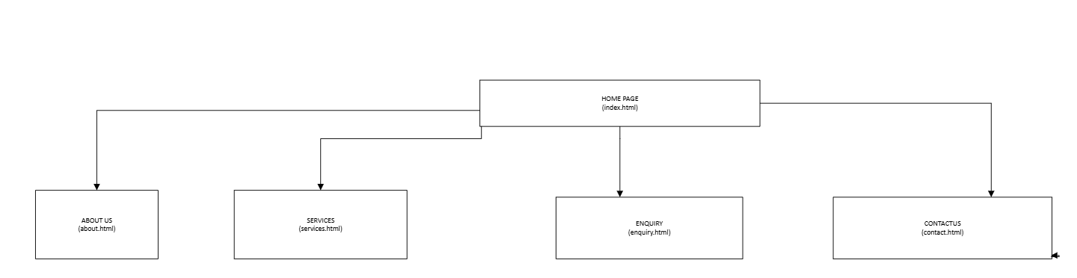
- Complete sitemap for Bophelo centre website
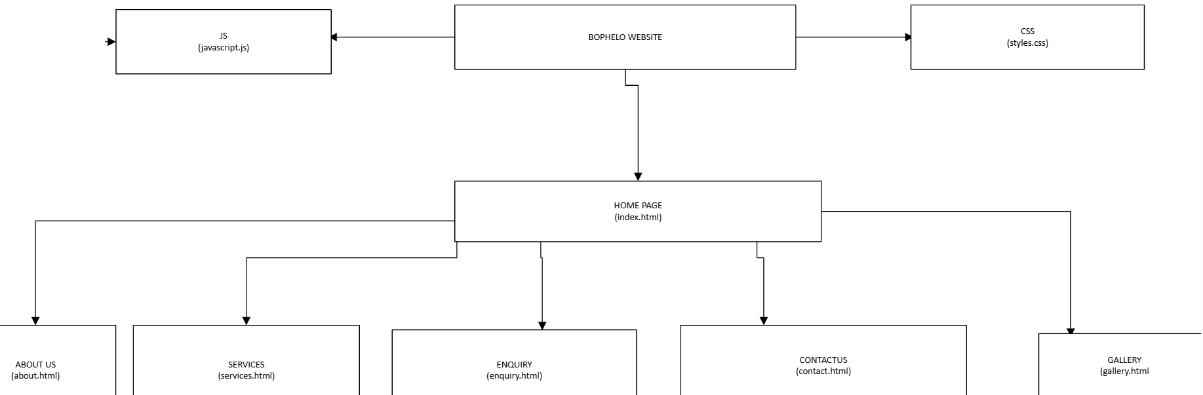
Design and User Experience
Design and User Experience (UX)
- Overall Design Aesthetic: The design is clean, professional, and welcoming, using modern medical web layouts with ample white space to create a trustworthy and calm tone for patients.
- Colour Palette:
  - Soft Lilac (#f3e8ff): Serves as the tranquil, welcoming background tone.
  - Electric Indigo (#4f46e5): Used for primary buttons, active navigation states, and clinical accents.
  - Deep Indigo Slate (#312e81): Applied to headings and structural elements for high readability.
- Typography:
  - Primary Font: Segoe UI / Aptos (Sans-serif) for body text to ensure modern legibility.
  - Header Font: Segoe UI Bold / Aptos Bold for visual hierarchy.
  - Hierarchy: Main Title (H1): 32px | Section Heading (H2): 24px | Sub-heading (H3): 18px | Body Text: 16px (1.5 line spacing).
- Layout and Design: A grid-based layout prioritizing mobile responsiveness, structured semantic HTML tags, and visual balance.
- UX Considerations: Intuitive sticky top navigation, accessible link states, consistent header and footer placements across all pages, and fast page load times through optimized media assets.
- Low-Fidelity Wireframes: Structural layout sketches outlining page hierarchy, header navigation, main content blocks, and footer alignment across standard desktop and mobile screens.
6. Technical Requirements
Hosting and Domain Requirements: A custom South African non-profit domain (.org.za) hosted on entry-level Linux-based web hosting with free SSL certification for secure user submission (or deployed via GitHub Pages).
Programming Languages & Tools:
- Markup & Styling: HTML5, CSS3 (Flexbox, CSS Grid, Custom Properties), Vanilla JavaScript (ES6).
- Development Tools: Visual Studio Code (VS Code) as the primary code editor.
- Version Control: Git and GitHub for tracking code revisions and remote repository management.
6. Technical Requirements
- Hosting and Domain Requirements: A custom South African non-profit domain (.org.za) hosted on entry-level linux-based web hosting with free SSL certification for secure user submission.
- Programming Languages & Tools:
  - Markup & Styling: HTML5, CSS3, Vanilla JavaScript (ES6).
  - Development Tools: Visual Studio Code (VS Code) as the primary code editor.
  - Version Control: Git and GitHub for tracking code revisions and remote repository management.
7.Timeline and Milestones
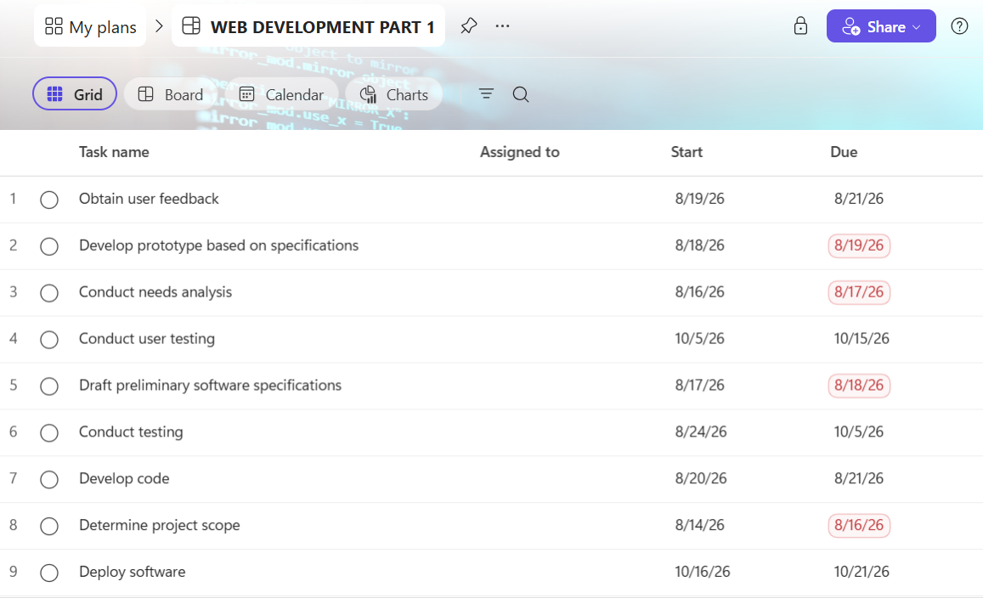
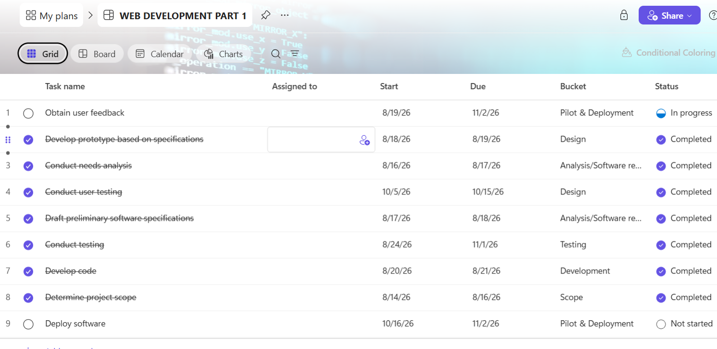
- Milestone 1 (Part 1 - Proposal & HTML Structure): Select organisation, submit Website Project Proposal, create initial semantic HTML skeleton files, configure folder structure, initialize local Git repository, and push to GitHub.
- Milestone 2 (Part 2 - CSS Layout & Responsive Design): Develop responsive CSS grid/flexbox layouts, apply colour palette and typography, implement wireframes, and test page layouts on multiple screen sizes.
- Milestone 3 (Part 3 - JavaScript Interactivity & Final Handover): Add JavaScript form validation, final testing across web browsers, update documentation and changelog in README.md, and complete final remote repository push.
8. Budget
- Local development :run on my own computer for free
- Web hosting : free on GitHub
9. References
- Hartman ,S.(2026).How to make a website: A step-by-step guide.https://www.godaddy.com/resources/skills/how-to-start-a-website-from-a-to-z?msockid=34ada4058a62633c165eb2b08ba56282.

- National department of health. (2024). NATIONAL INTEGRATED MATERNAL AND PERINATAL CARE. GUIDELINES FOR SOUTH AFRICA. Integrated Maternal and Perinatal Care Guideline Final 4 October 2024 DG signed.pdf.

